Experiment-2
Section-2
Name | Lastname | ID
Yunus Emre | Turunç | 150721854
Semiha | Şen | 150720018
Sezgin | Er | 150720060
Fatma | Atak | 150720014

Pre-LAB Work
- For the circuit given in Fig. 1, calculate the differential mode (Vout/Vid) and common mode (Vout/Vcm) voltage gains. Ignore the Early Effect and assume that all the transistors are operating in active mode. Vcc=15V and Vee=-15V.
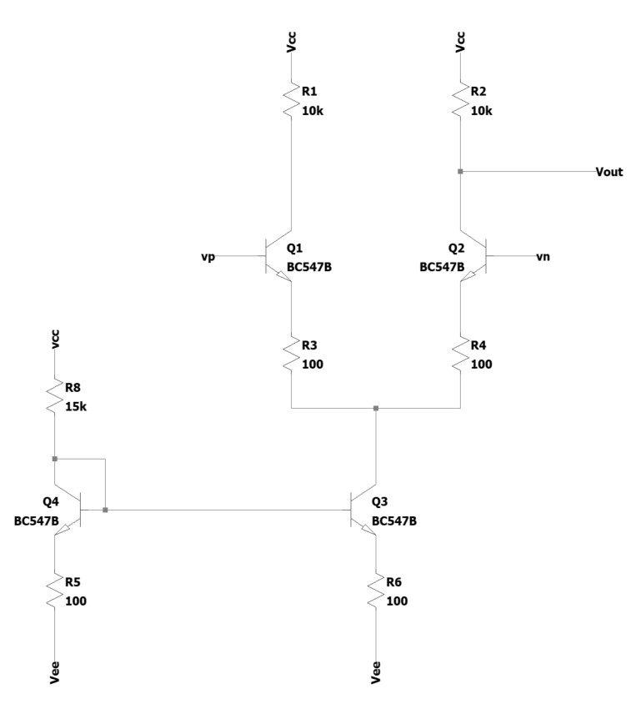
Figure 1
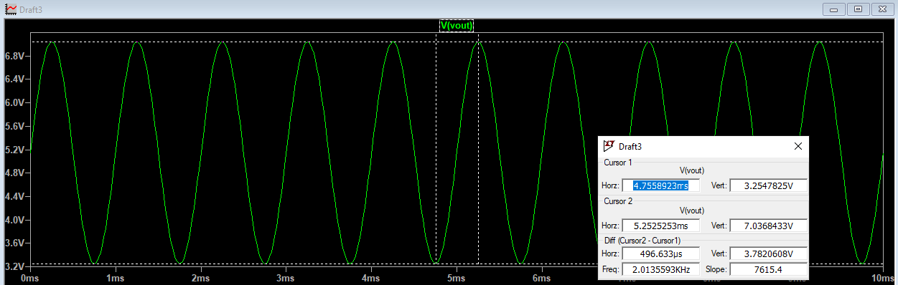

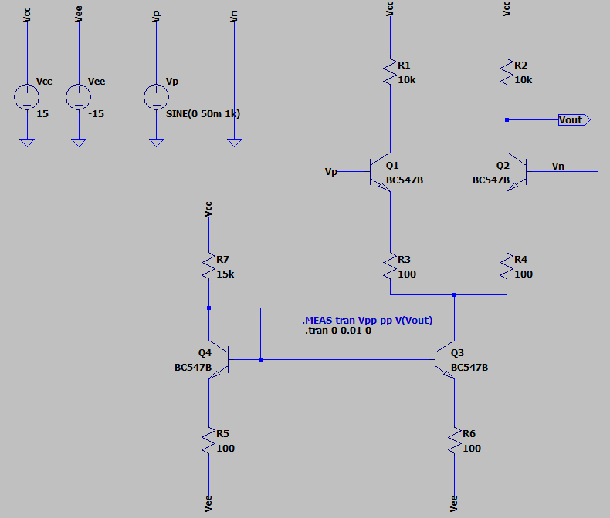

- Simulate the circuit in Fig. 1 with SPICE. Let Vcc=15V and Vee=-15V. Apply a sine wave of 1kHz with an amplitude of 50mV to vp and connect vn to ground. Measure the differential mode voltage gains.
Ad=(Vout[peak-to-peak]/100mV) = 37.82 V

- Simulate the circuit in Fig. 1 with SPICE. Let Vcc=15V and Vee=-15V. Apply a sine wave of 1kHz with an amplitude of 50mV to both vp and vn. Measure the common mode voltage gains.
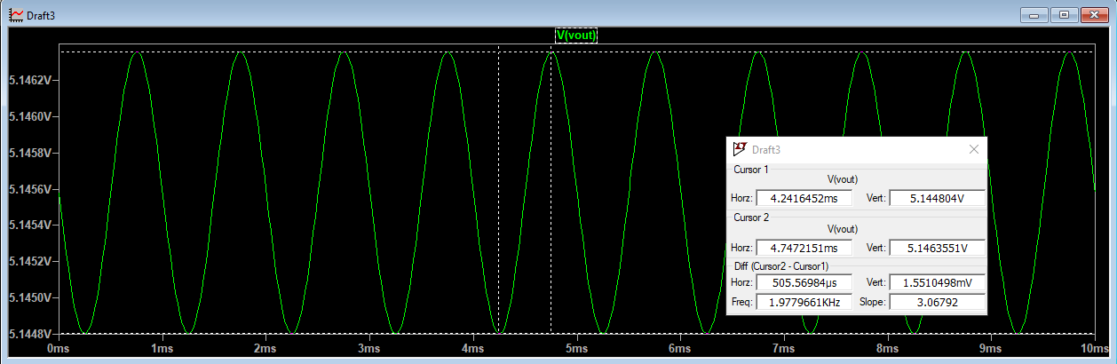

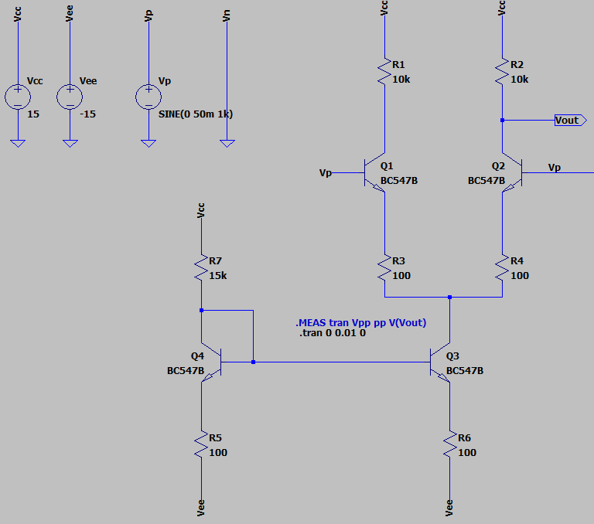

Ac=(Vout[peak-to-peak]/100mV) = 15.5 mV

Equipment/Component List
Table 1: Equipment/Component List
Equipment/Component | Model/Value | Count
Breadboard | - | 1
Resistor | 100Ω | 4
Resistor | 10kΩ | 2
Resistor | 15kΩ | 1
BJT (npn) | BC547 | 4
Multi-meter | - | 1
Voltage Source | 15V, -15V | 1
Probes & Cables | - | -

Experiment Procedure
- Adjust Vcc to 15V and Vee to -15V.
- Set-up the circuit in Fig. 1.
- Connect Vn to ground.
- Apply a sine wave of 1kHz with an amplitude of 50mV to Vp.
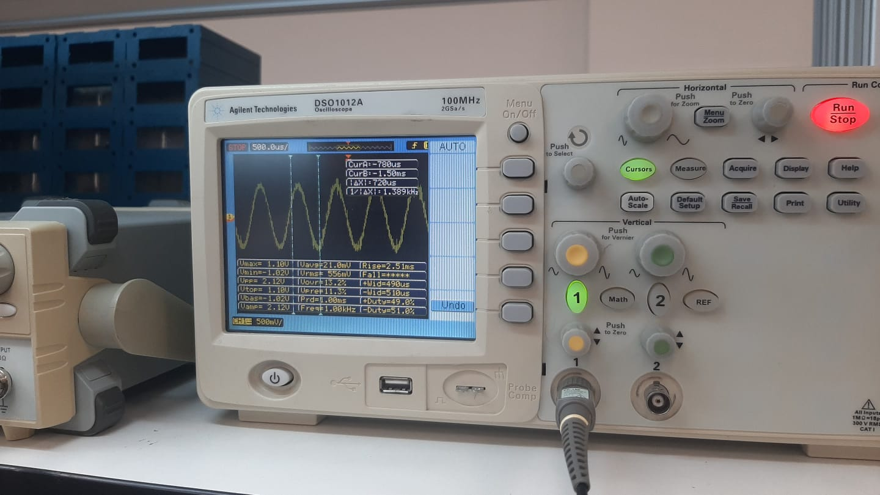
- Plot Vout and measure the peak-to-peak value of the output.
Plot:

- Calculate the differential mode voltage gain.
Ad=(Vout[peak-to-peak]/100mV)= (1.10-(-1.02)/100mV=21,2V
- Remove the ground connection from Vn and then connect Vn to Vp.

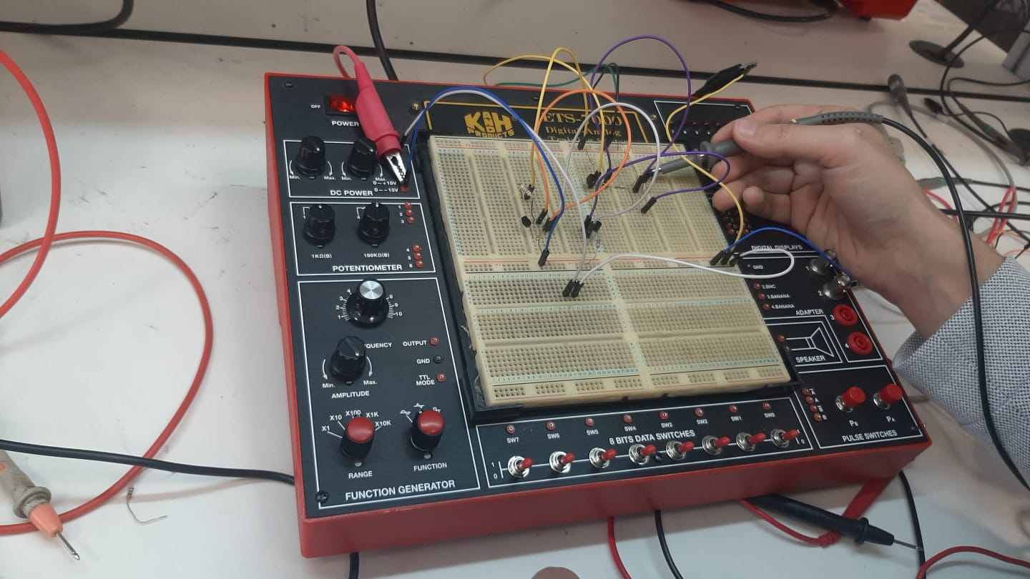

- Calculate the common mode voltage gain.
Ac=(Vout[peak-to-peak]/100mV)= (1.12-(-1.08))/100=22V
- Compare the simulated (2, 3) and measured (9, 11) common and differential mode voltage gains.
Answer:

